Bliain dár Saol i gColáiste Chilliain – 2019-2020
A Year in the Life of Coláiste Chilliain - 2019-2020

Cé gur dúnadh an Coláiste ar an 12ú Márta, 2020 d’éirigh linn an t-uafás a dhéanamh sa scoilbhliain áirithe seo. Molaimid ár ndáltaí, ár dtuismitheoirí agus ár múinteoirí a bhí páirteach sna himeachtaí seo go léir.
Although the school closed on March 12, 2020 we managed to fit an exceptional amount of activity into this particular school year. We are so proud of our pupils, parents and teachers who have contributed to these activities.

Turas Bhliain 1 chuig Oileán Acla - Meán Fómhair 2019 / September 2019
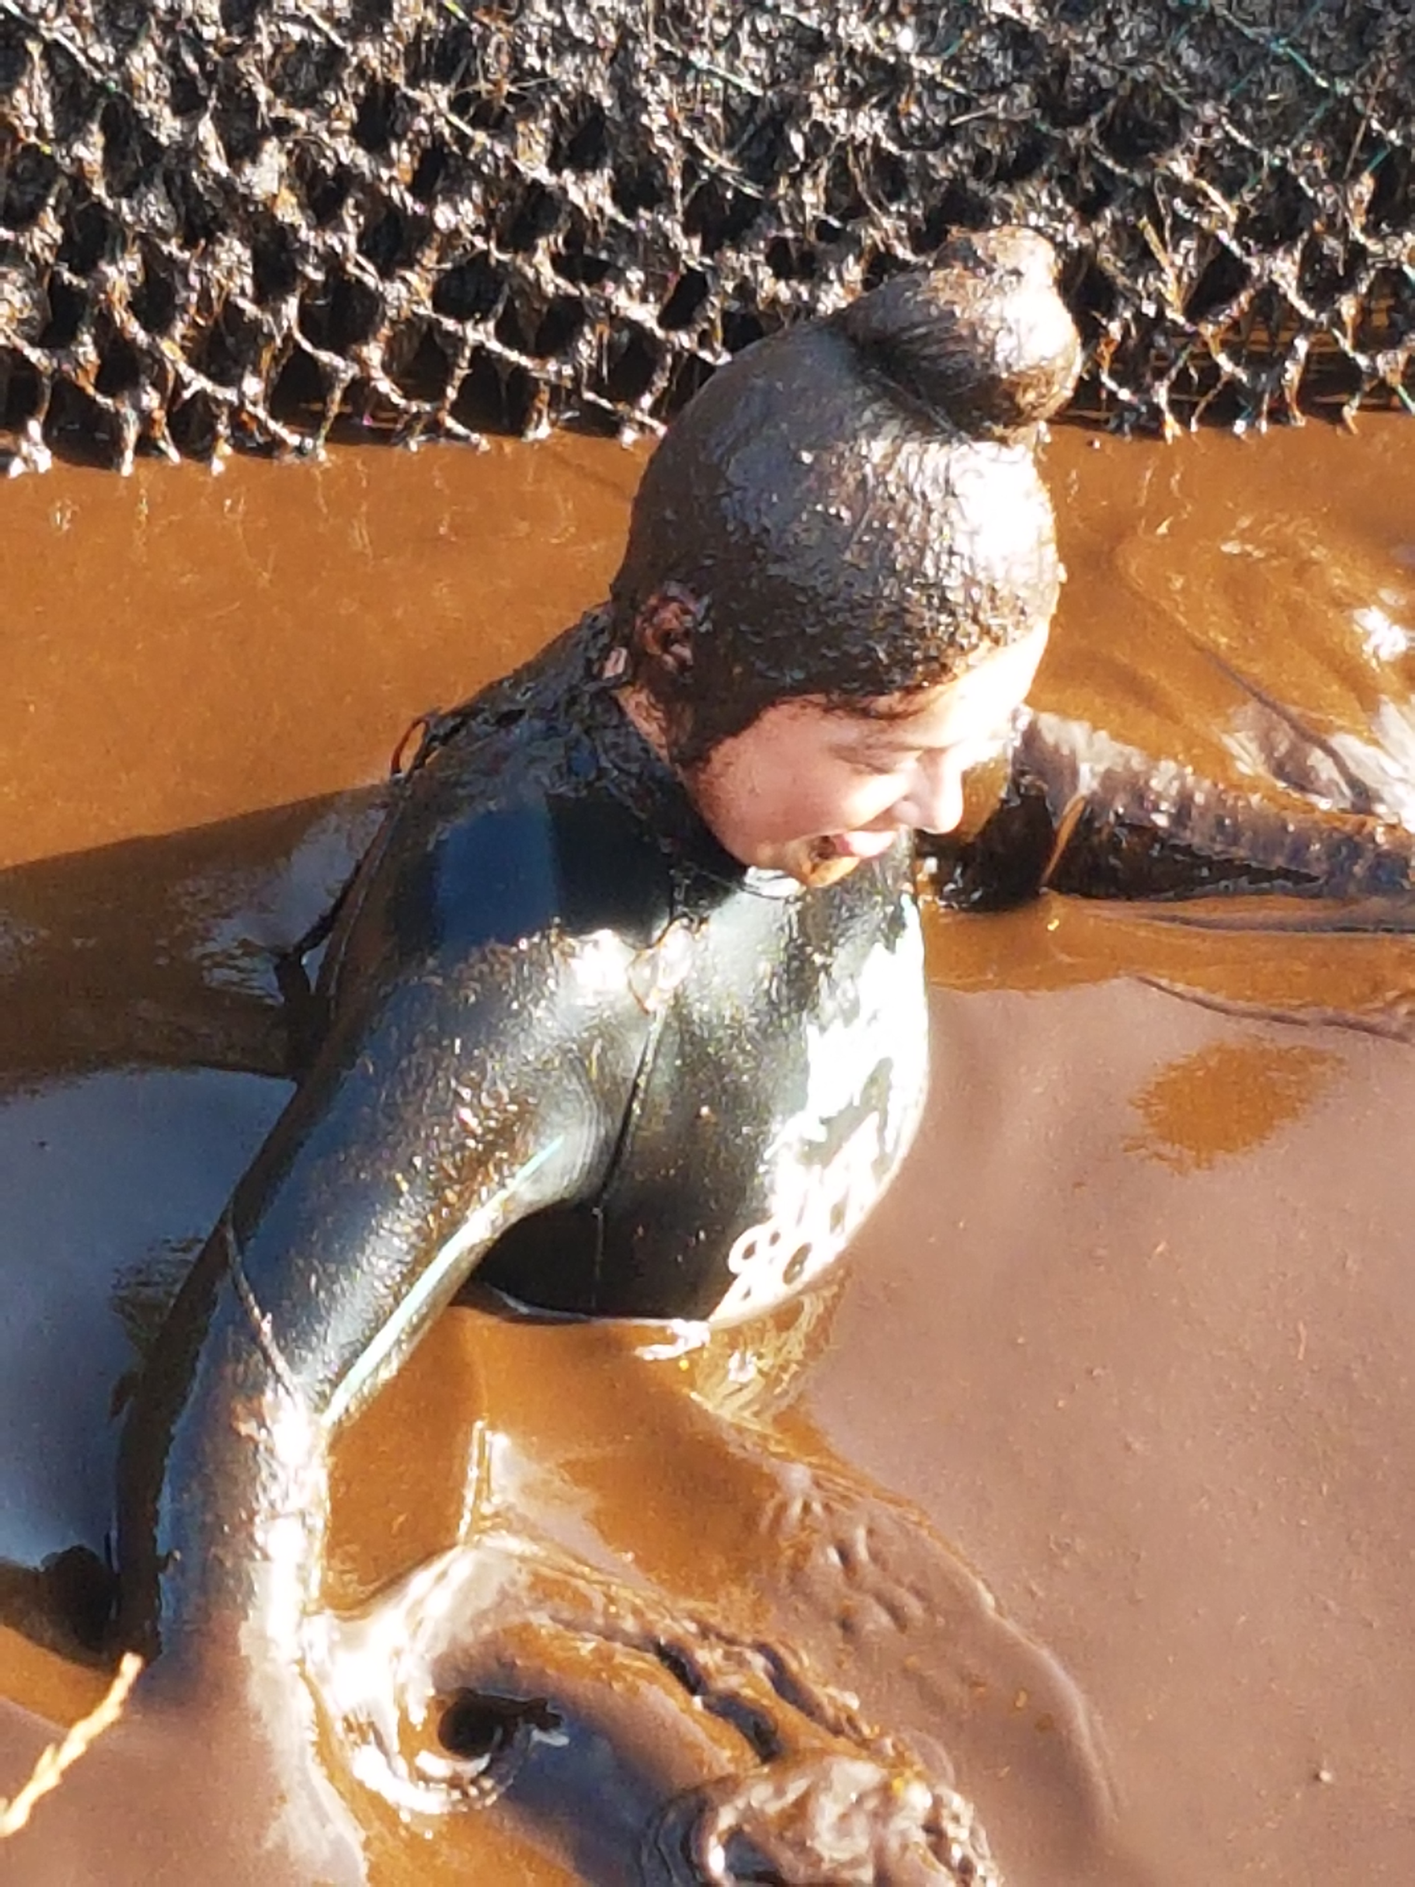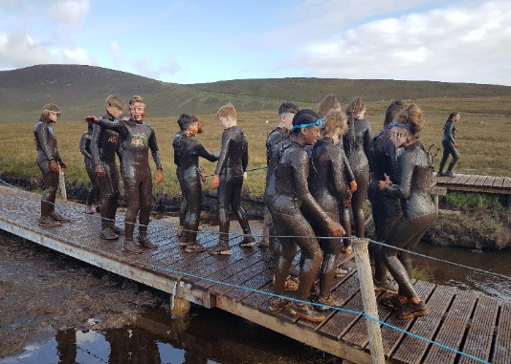
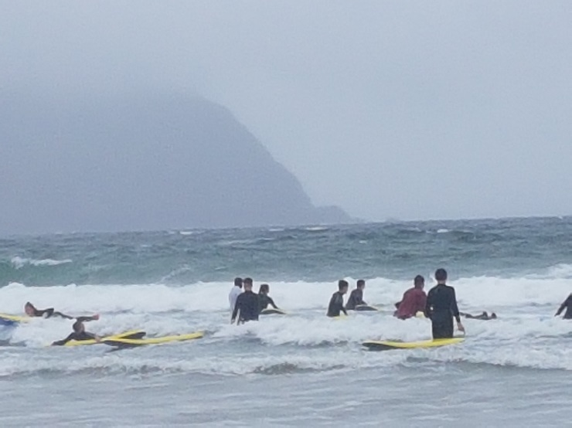

Bhí turas iontach ag 97 dalta céad bliana chuig Oileán Acla idir an 8ú agus 10ú Meán Fómhair 2019. Chuamar ag spraoi sa phortach, ag marcaíocht na dtonnta, ag léimt na hailltreacha agus ag siúl na sléibhte. Is t’oíche bhí ceilí agus cluichí sa halla mór. Bhí an aimsir ar an Luan ar-fheabhas agus chaitheamar a lan ama ar an bhfarraige, sa bhfarraige, faoin fharraige. Tugadh ard-mholadh dár ndaltaí faoin méid Gaeilge a labhair said. Bhíodar bríomhar go maith ach i gcónaí béasúil. Thaisteal Feargal agus Martha leo.
Ninety seven first years travelled with Feargal and Martha to Achill Island from September 8th to 10th. We all had a wonderful time, surfing, cliff jumping, hill walking, bog swimming. In the evenings we had a Céilí and games. The sun shone on the second day and we spent most of the day on, in and under the water!! Our pupils were highly praised for their Irish and their manners.

Scoláireachtaí / Scholarships – Meán Fómhair / September 2019

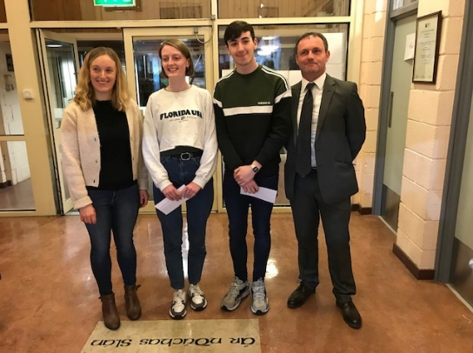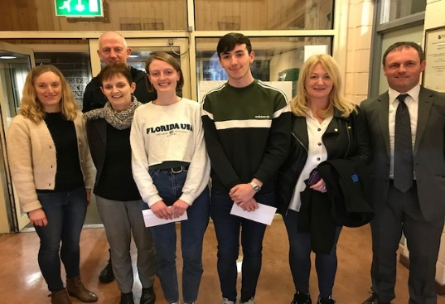
Tá comhgáirdeachas ollmhór ag dul dár mbeirt buaiteoir ar Scoláireacht Cairde Chilliain. Cuireann Cairde Chilliain an scoláireacht ar fáil do scoth-scoláire na bliana agus don dalta a ghnóthaigh na marcanna is airde san Ardteist. An t-aon coinníoll ná go bhfreastalaíonn na daltaí ar an Ollscoil le céim a dhéanamh. I mbliana bhuaigh an dalta céanna an dá dhuais – Caoilfhionn Ní Dheoráin agus sa chás sin ghnóthaigh an dalta leis an dara méid pointí is aired an dara scoláireacht – Seán Ó Dúill.
Tá Caoilfhionn ag déanamh staidéar ar Ríomheolaíocht i gColáiste na Trionóide agus Seán Ó Dúill ag déanamh teiripe saothair I gColáiste na Trionóide freisin. Táimid iontach bróduil astu agus go n-eirí go geall leo ina ngairmeacha amach anseo. Bhronn Deirdre Ní Shuilleabháin thar ceann Chairde Chilliain seic an duine ar luach €500 an ceann dóibh ar an Oíche Fáilte do bhliain 1.

Congratulations to our two Cairde Chilliain Scholarship winners for 2019. Cairde provide two scholarships every year, one for the Pupil of the Year and the second for the highest point scorer in that year’s leaving Cert. As the same person, Caoilfhionn Ní Dheoráin occupied both positions (a unique achievement in itself) the second highest point scorer, Seán Ó Dúill received the second scholarship.
Caoilfhionn is studying Computer Science in Trinity College and Seán is also in Trinity, studying Occupational Therapy. We are immensely proud of them and wish them every success in their future careers. Deirdre Ní Shúilleabhain presented the scholarships worth €500 each on behalf of Cairde Chilliain on our first year Welcome Night.

TURAS go UGANDA Deireadh Fómhair / October 2019

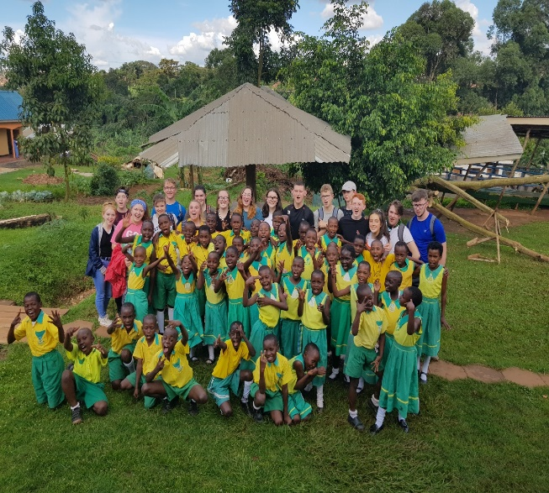
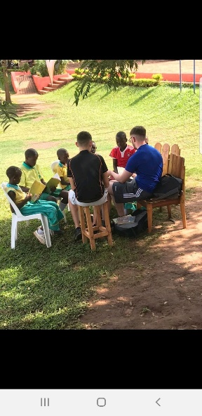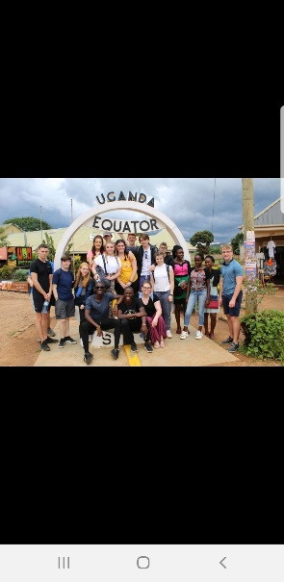
Chuaigh triúir mhúinteoir agus seachtar déag dalta go Uganda i mí Deireadh Fómhair 2019.
Chuamar ar feadh deich lá. I rith an tréimhse bhí go leor ar siúl againn! Bhí garraíodóireacht, léitheoireacht le páistí ó bhunscoileanna áitúla, thógamar teach gloine as búidéil phlaisteacha athchúrsáilte, thugamar cuairteanna ar thithe daoine áitiúla, thugamar cuairt ar roinnt gnó áitiúil. Chaitheamar am le déagóirí ar comhaois leo chun na difríochtaí ó thaobh dúshláin a phlé lena chéile. Thugamar cuairt ar an ospidéal atá ag ‘Nurture Africa’ agus na scoileanna eile atá acu ar shuíomh ‘Nurture Africa’. Thugamar cuairt ar mheánscoil áitúil, thug an turas seo deis dúinn na difríochtaí atá ann idir ár scoil féin agus scoil Uganda a fhéiceáil. Chuamar amach ag siúl go minic agus fuaireamar an deis an ceantar a fhéiceáil ar bhlealach difriúl. Thugamar cuairt ar Ambasáid na hÉireann i Kampala, fuaireamar amach faoin dea-oibre ar fad atá ar siúl ag an Ambasáid agus fuaireamar deis bualadh leis an Leas Ambasadóir. Ag an deireadh ar fad chuamar ar thuras suas go ‘Murchison Falls National Park’ i dtuaisceart Uganda. Tar éis cúpla lá deacair agus taitneamhach bhí an deis againn ár scíth a ligean agus a bheith sánaithe sa nadúr dochreidte mór thimpeall orainn. Turas den scoth a bhí ann agus ní dhéanfaidh muid dearmad air go deo!
Three teachers and 17 pupils travelled to Uganda in October 2019 for 10 days organised by the Nurture Africa charity. The pupils visited local primary schools, local businesses, Nurture Africa hospitals. They played and read with the primary pupils and spent time comparing their own lifestyles and education experience with their Ugandan peers in a secondary school.
They also had an opportunity to see the area and were welcomed by the Irish ambassador in Kampala where they learnt of the aid programme run by the embassy. They visited the ‘Murchison Falls National Park’ in northern Uganda and were then able to relax in the extraordinary natural beauty and wildlife around them. It was an experience of a life time and the memories will be treasured forever. Many thanks to múinteoirí Caitríona and Sorcha and especially Emily for organising the whole campaign.

Cúrsaí Cheoil – Scléip – Samhain / November 2019
Ar an Déardaoin 28ú^{h} Samhain, ghlac Niamh Nic Risteard agus Hannah Ní Mhathúna ó bhliain 3 agus Amy Ní Uallachain, Olivia Caomhánach agus Emí Ní Choigligh ó bhliain 2 páirt i ‘Scléip’, comórtas cheoil. Sheinn Hannah an giotár agus bhí sí ag canadh freisin. Chan sí amhrán de chuid ‘Radiohead’ ó scannán agus bhí sí an-mhaith. Chan Niamh amhrán de chuid ‘Imagine Dragons’ agus bhain sí úsáid as an rian tacaíochta. Bhí grupa cailíní ó bhliain 2 ag seinm freisin. Sheinn Olivia an pianó agus chan Amy agus Emí amhrán Ed Sheeran. Bhí na cailíní ar-fheabhas agus bhain siad taitneamh as an lá agus an comórtas agus tá an scoil an-bhródúil astu.

A group of students participated in ‘Scléip’, a music and talent competition as Gaeilge on Thursday, November 28th. Niamh Nic Risteard and Hannah Ní Mhathúna from 3rd year and Amy Ní Uallachain, Olivia Caomhánach agus Emí Ní Choigligh from 2nd year represented Coláiste Chilliain. They played songs from Radiohead, Imagine Dragons and Ed Sheeran – as Gaeilge of course. Their performances were top class, using guitar, piano and backing tracks and the school is very proud of them. They enjoyed the experience and hopefully will participate again next year and proceed to the next round.
CÓR – tá cór scoile bunaithe ag Mairéad agus bualann said le chéile ag am lóin gach Aoine. Tá an t-uafás talann amhrán aíochta sa scoil agus seo deis na guthanna binne sin a úsáid.
Mairéad has set up a school choir that meets at lunchtime in the music room every Friday. The school is alive with singing talent and this would be a great opportunity to hear their dulcet tones!
Rinne daltai trialacha le haghaidh an Féile Cheoil, eagratihe ag DDLETB sa cheoláras Náisiúnta le déanaí – ceoltóirí den chéad scoth iad ach tá an comórtas an-ard I mbliana agus beidh orthu triail a bhaint as arís an bhliian seo chugainn.
Pupils also auditioned for the DDLETB Festival of Music in the National Concert Hall. Although they are top musicians the standard must be extremely high as they were not chosen. Hopefully they will prove successful next year.

Gaeilge 24 – Samhain/November 2019
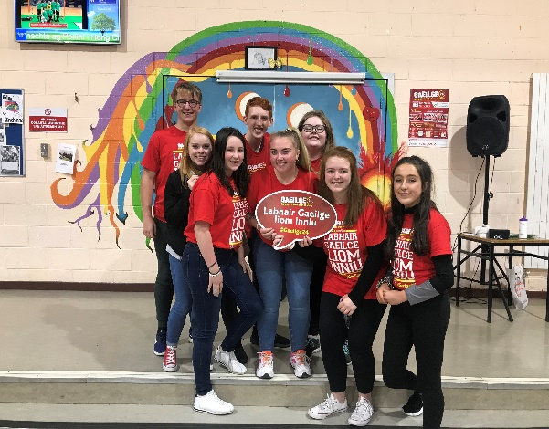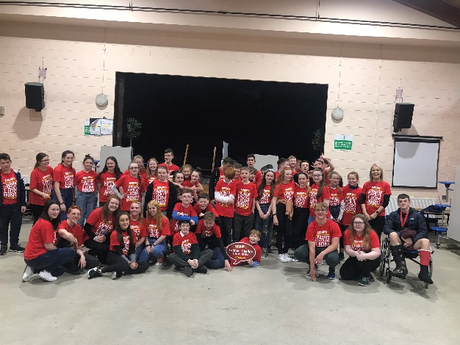
Ar an 12 Samhain ghlac 107 duine, idir dhaltaí agus mhúinteoirí, ó Choláiste Chilliain páirt i nGaeilge 24. Ba í aidhm an dúshláin seo ná daoine óga a spreagadh chun labhairt as Gaeilge amháin ar feadh 24 uair a’ chloig: sa bhaile, ar scoil, i siopaí agus i ngnólachtaí, timpeall an bhaile áitiúil, sa chlub spóirt agus lena gcairde! Tá fás agus forbairt ag teacht i gcónaí ar líon na ndaltaí a ghlacann páirt agus baintear an-spraoi as an ócáid. I mbliana, chuir múinteoir Aoife Ní Dhéisigh, le cabhair ón ngrúpa Gluais, céilí ar siúl sa bhialann agus bhí an-chraic ag na daltaí agus iad ag foghlaim leithéidí ‘Ballaí Luimnigh’ agus ‘An Dreoilín’. Tar éis na scoile, chuir Meadhbh Ní Cheallaigh scannáin trí Ghaeilge ar siúl dóibh siúd a raibh fonn orthu níos mó ama a chaitheamh sa scoil chun an dúshlán a chomhlíonadh. Ar an iomlán ,bhí an-lá go deo againn agus tá súil againn cur le linn na ndaltaí a ghlacfaidh páirt san ócáid amach anseo.

On the 12 November, 107 students and teachers from Coláiste Chilliain participated in Gaeilge 24. The aim of this challenge was to encourage young people to try and speak Irish for one whole day, for 24 hours: at home, at school, in shops and businesses, around the town, in sports clubs and with friends! Gaeilge24 has grown over time with an increased number of students participating each year and they really enjoy the occasion. This year, Aoife Ní Dheisigh, with the help of the ‘Gluais’ group, organised a céilí for the students. They had great fun learning various dances for example, ‘Ballaí Luimnigh’ and ‘An Dreoilín’. After school, Meadhbh Ní Cheallaigh treated those students who wanted to stay in school a little longer to fulfil the challenge to some movies ‘as Gaeilge’. On the whole, it was a thoroughly enjoyable day and we hope that more and more students participate in the future.

Eolaí Óg – Young Scientist – Eanáir / January 2020
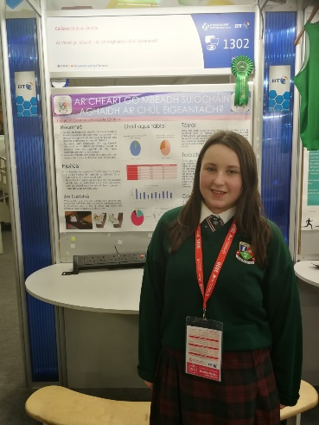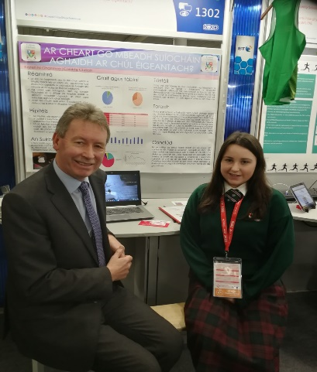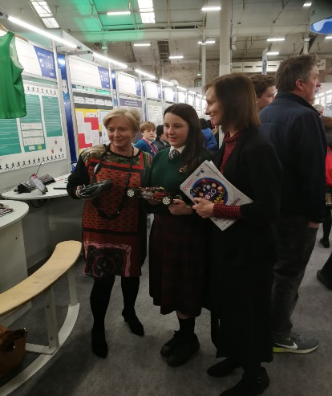
Taimid fíor-bhródúil as ár dtoscaire chuig an Eolaí Óg i mbliana, Kirsten Nic Gamhna ó bhliain 5, Rang Darach. Rinne sí a tionscnamh ar suíocháin leanaí i gcaranna, ag díriú ar an slí is sábháilte leis an suíochán a chur sa charr. Fuair sí ard-mholadh ar an obair agus bhain sí an-sult go deo as an taithí. Molaimid go hard í.
We are extremely proud of our participant in this years Young Scientist competition, Kirsten Nic Gamhna, Rang Darach, 5th year. Her project focused on baby seats and how best to position them in cars. She revceived a commendation for her project and she reported that she thoroughly enjoyed the experience. Well done Kirsten !

Global Ireland – Cuairt an Ambasadóra – Eanáir / January 2020
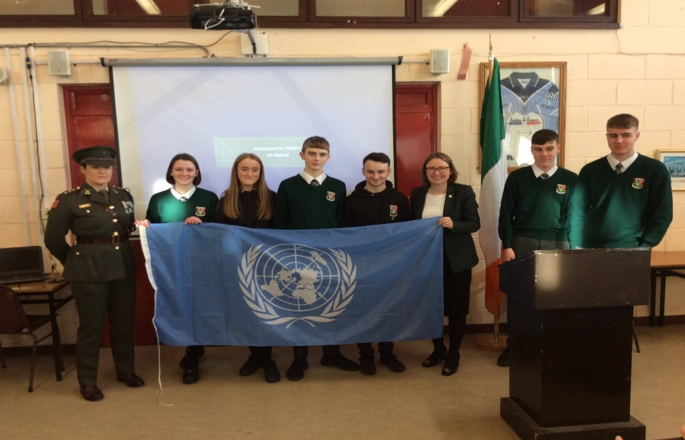

Mar chuid d’fheachtas an Rialtais Éire a chur chun cinn go hidirnaisiúnta agus ról na tíre ar bhonn domhanda a leathnú chuaigh 50 ambasadóir de chuid na tíre seo ar chuairt chuig meán scoileanna ar an 9ú Eanáir 2020. Chuaigh ball d’óglaigh na hÉireann in éineacht leo chun ár ról sna Naisiún Aontaithe a mhíniú. (Tá Éire ag lorg suíochán ar an gComhairle Slándála faoi láthair). Bhíomar iontach bródúil gur thainig beirt iar-dhalta ar ais chugainn chun é sin a dhéanamh – Ambasadóir Deirdre Ní Fhallúin (Ambasadóir chuig an Chipir) agus an Captaen Naimh Ní Dhroma. Rinneadar cur i láthair an-shuimiúil agus eolach ar tábhacht ár ról thar timpeall an domhain.

As part of a Government initiative to expand Ireland’s footprint around the world 50 ambassadors visited schools around the country on January 9, 2020. They were all accompanied by a member of the Defence Forces in order to illustrate the role Ireland plays in the United Nations as peace Keepers around the world. Ireland is also seeking a seat on the UN Security Council.
It was a matter of great pride that the delegates sent to Coláiste Chilliain were two past pupils, Deirdre Ní Fhallúin ( Ambassador to Cyprus) and Captain Niamh Ní Dhroma from the Defence Forces. They gave a fascinating description of their roles and responsibilities and the the great work done on our behalf around the world.

Tógáil - Building
Ar deireadh thiar thall tá na leithris nua tógtha agus iad ar ard-chaighdeán. Tosaíodh an obair ag deireadh mí an Mheithimh agus críochnaíodh iad díreach sular fhill na daltaí chugainn. Iarraimid ar gach dalta aire a thabhairt dos na leithris agus gan ligint don chaighdeán atá ann anois a shleamhnú.
Maidir leis an gCampus Lán-Ghaeilge – tá moill (EILE) curtha leis de bharr gur dhún an comhlacht ailtireachta a bhí ag obair ar an dtogra síos. Caithfear comhlacht eile a aimsiú sular féidir leanúint ar aghaidh. Táimid dóchasach go dtosóidh an obair san athbhliain!!
At long, long last we have renovated the toilets in Coláiste Chilliain under a 2016 Summer Works scheme!!! However I would ask parents to impress on their children the importance of maintaining the toilets and keeping them clean.
With regard to the Campus lán-ghaeilge there is yet ANOTHER delay as the architect firm involved has gone into liquidation which means the project managers must appoint a new firm. This should result in a further delay. We can only hope that the work can begin early in the new year.

iPads – Cairde Chilliain
Táimid fíor-bhuíoch do Chairde Chilliain as ucht €5K a chur ar fáil don scoil le boisca iPads nua a cheannacht dár ndaltaí. Tá 3 bhosca again cheana féin agus baintear an-úsáid astu. Tá éileamh mór ann dóibh agus cabhróidh sé le múinteoirí agus daltaí ach go háirithe agus iad ag tabhairt faoi na measúnaithe rang-bhunaithe don SS nua.
We are very grateful to Cairde Chilliain – the Parent Council body for the donation of €5K towards purchasing another set of iPads. Access to iPads as an educational tool is the aim of the school without the added costs of asking parents to bear the burden of an iPads per pupil. The three sets we currently have are being constantly used and they should prove very useful when undertaking the new Classroom Based Assessments of the new Junior Cycle.

Múinteoirí nua
Fiach Mac Conmara: Adhmadóireacht/Foirgníocht/ Grafaic Theicniúla/ Spórt
Pádraig Ó Maonaigh: Miotalóireacht, Innealtóireacht/ Grafaic Theicniúla/ Teicneolaíocht/ Spórt
Aoife Ní Dhéisigh: Eacnamaíocht Bhaile/Gaeilge
Laura Nic Thomáis: Ríomhaireacht/Eolaíocht/Mata
Diarmuid Ó Beaglaoí: Eolaíocht/Mata

Idirbhliain / TY (M. Fómhair/ Sept 2019 – Feabhra / Feb 2020)
Is iad seo a leanas na turais agus gníomhaíochtaí éagsúla atá déanta ag daltaí na hidirbhliana go dtí seo !!! Some of the activities undertaken by the TY pupils so far this year:

- Cúrsa Tiomána / Driving lessons

- Bahbhláil / Bowling Ceardlann Timpist Carr / Car Accident Simulator

- Teanga Comhairtheorach / Sign Language

- Módúil Chéad Cabhair / First Aid Module

- Turas GTR / Guidance

- GoQuest

- Scoil Glacaíochta / Gymnastic School visit

- Drumadóireacht / Drumming

- Ceardlann Agallamha / Interview Workshop

- Priosún Chill Mhaighnéain / Kilmainham Prison

- OTBÁC – Seachtain na hEolaíochta/ TUD –Science Week

- Feirm Causey / Causey Farm

- Ceardlann leis an Comhar Creidmheasa/ Credit Union workshop

- Scátáil Oighir / Ice skating

SPÓRT
Ghlac foirne sacair, peil gaelach, iománaíochta agus cispheile páirt i gcomórtais éagsúla ó thús na bliana.
- D’éirigh leis an fhoireann peil gaelach f/18 craobh a shroichint ach níor imríodh é de bharr na haicíde ach tá caint ar an craobh a imirt i mí Meán Fómhair 2020. U/18 - Final
- Shroich an fhoireann peil gealach f/16 an ceathrú craobh in a gcomórtas. U/16 - ¼ Final

- Shroich an fhoireann sacair sinsireach an ceathrú craobh in a gcomórtas. U/19 ¼ Final
- Shrpoich an fhoireann sacair f/15 an leath craobh in a gcomórtas. U/15 – Semi-final

- Shroich an fhoireann iomanaíochta f/16 an craobh in a gcomórtas. U/16 - Final

- Bhí foirne cispheile buachaillí & cailíní cláraithe i gcomórtais freisin.
- Shroich cailíní bhliain 1 agus bhliain 3 an ceathrú craobh agus shroich cailíní bhliain 2 an leath chraobh, nár imríodh faoin am a dhún na scoileanna. 1st & 3rd year girls – ¼ Final
2nd year girls – Semi-final (unplayed)
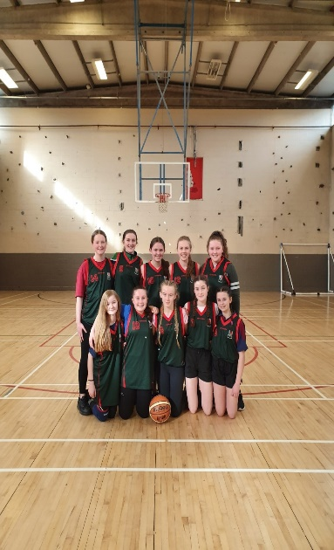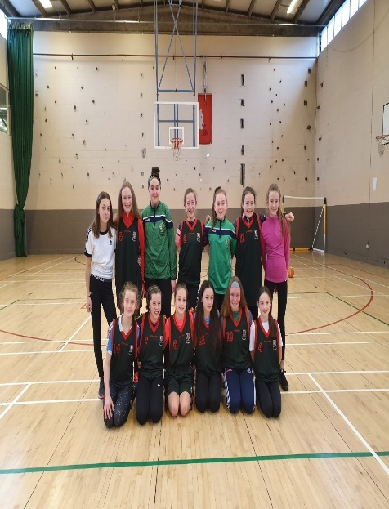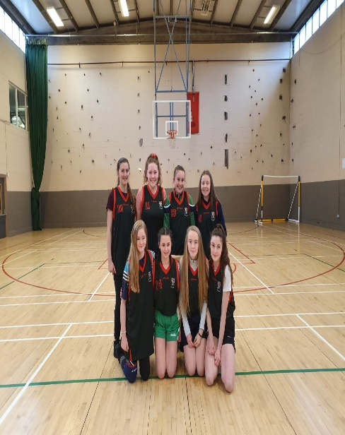

Díospóireacht / Debating
Bhí foireann shóisearach agus shinsireach páirteach sna comórtais díopóireachta I mbliana – cé go ndearna an fhoireann shóisearach éacht ar an oíche níor éirigh leo dul níos faide ná an céad babhta. Bhíomar an-bhródúil as an bhfoireann shinsearach a shroich an leath chraobh náisiúnta.
Junior debate team – 1st round, Senior debate team National semi-finals.

TURAS SCIÁLA / Skiing Trip – Feabhra /February 2020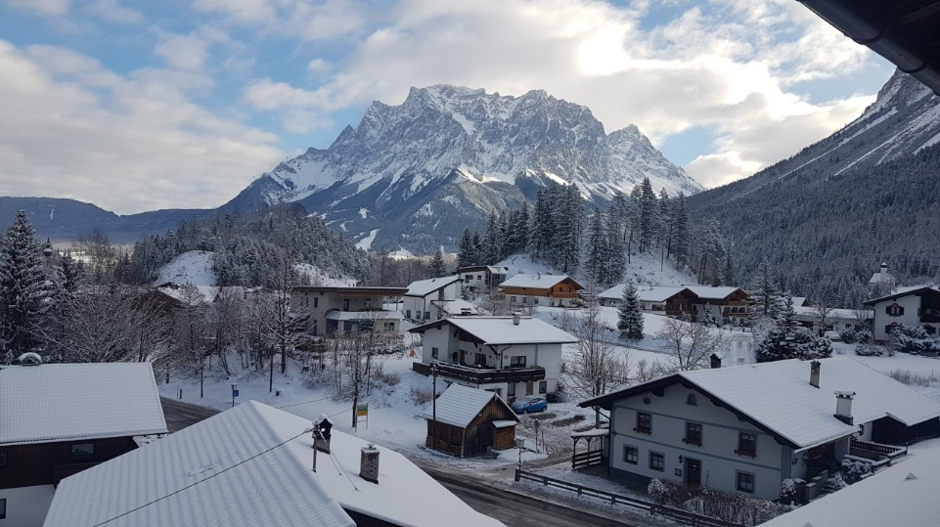 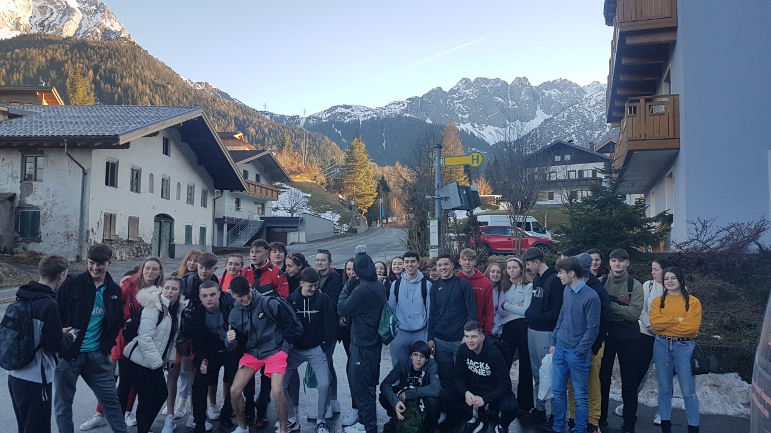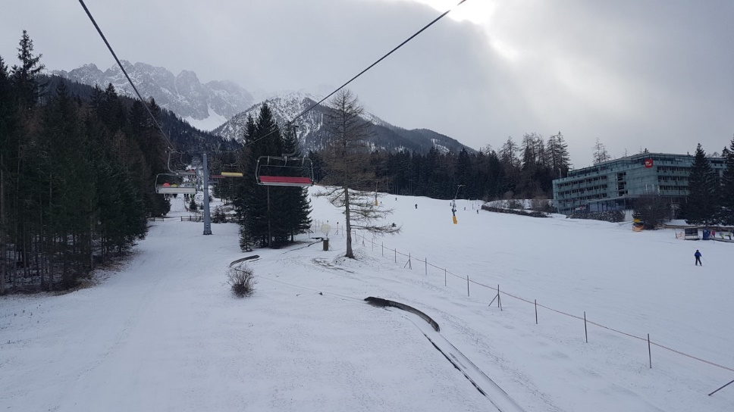

Chaith daltaí na hIdirbhliana maraon le ceathrar múinteoir, nach mór seachtain ag sciáil san Ostair i mí Feabhra 2020. Bhíomar lonnaithe i Biberwier in aice leis an Zugspitze (an Sliabh is airde sa Ghearmáin). Cé go raibh ganntanas sneachta ann ag an tús thug sé deis duinn na scileanna scíala a fhoghlaim. Tháinig an sneachta trom leath bealach tríd agus bhíomar réidh chun tabhairt faoi na fánaí géara. Bhí na daltaí ar-fheabhas ag scíáil agus d’éirigh le formhór daoibh tabhairt faoi na fánaí is deacra. Thugamar cuairt ar Garmisch Partenkirchen (áit ar tionóladh na cluichí oilimpeacha 1936) agus ar bailte beaga timpeall an cheantair. Is turas den chéad scoth a bhí ann agus mór-bhuíochas do Mhaebh Ní Chléirigh a d’eagraigh é.
The TY pupils and 4 teacher spent nearly a week skiing in Biberwier, Austria in February 2020. Biberwier is located on the Austrian side of the highest mountain in Germany, the Zugspitze. We were nearly all beginners and started on the baby slopes (with varied success) before we moved to the more challenging slopes. Along with the challenge came the long awaited heavy snowfall. The pupils were excellent skiers and most managed to ski the most difficult slopes. We also visited Garmisch Partenkirchen, which hosted the 1936 Olympics and many of the towns in the surrounding area. It was an excellent trip (no injuries apart from to some teachers’ pride!!!) and our heartfelt thanks goes to Maebh Ní Chléirigh who organised it all.

Gluais
Tá grúpa daltaí sa chúigiú bhliain ag cabhrú leis an scoil cúnamh a thabhairt do dhaltaí na céad bliana socrú isteach sa scoil. Tá roinnt imeachtaí eagraithe acu cheana féin leo agus is iontach an rud é go bhfuil na daltaí sásta tabhairt faoin obair thábhachtach agus fhiúntach seo.
Gluais is a student pastoral care initiative where 5th years go on a training course (voluntarily) and organise events and meetings in order to help first years integrate into the school. It is a testament to the calibre of those individual volunteers the amount of work which they have undertaken in support of our first years.

Iardhaltaí – Past Pupils – Polaitíocht/Politics!
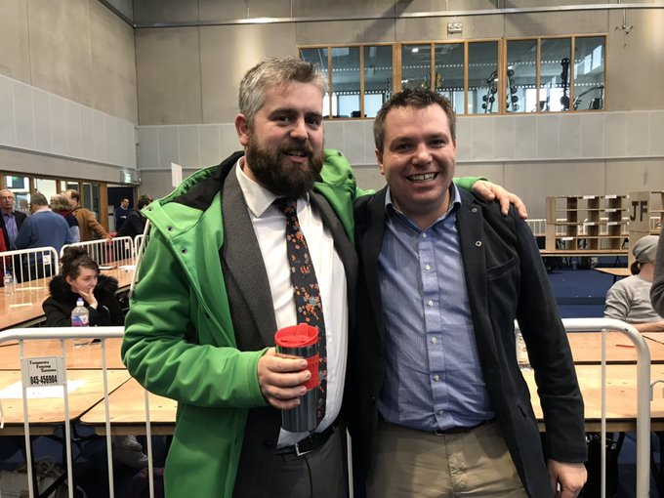

Is cúis bhróid dúinn i gColáiste Chilliain gur toghadh cúigear iar-dhalta mar Chomhairleoirí sna toghcháin áitiúla mí Bealtaine seo caite. Chomh maith le sin sheas beirt acu sa fo-thoghchán i mBÁC thiar-lár le déanaí. Bhuaigh tuismitheoir na scoile seo an suíochán úd – Mark Ward.
Is iad an bheirt a sheas ná Peadar Ó Caomhánaigh –Comhaontas Glas (ar chlé sa ghriangraf thuas) agus Séin Ó Muineacháin – Fianna Fáil (ar dheis sa ghriangraf thuas). Is Comhairleoirí iad ar Chomhairle Chontae BÁC Theas – in éineacht le Liam Sinclair (Comhaontas Glas), Eoin Ó Broin (Neamhspleách). Toghadh Hazel de Nortún ar Bhárdas Átha Cliath (Pobal roimh Brabús).
It is a cause of great pride to us that 5 past pupils were elected councillors in the Local Elections in May 2019. Two of the five also stood in the Dublin Mid-West by-election which was won by Mark Ward (Sinn Féin) a Coláiste Chilliain parent.
The successful councillors who stood in the by-election were Peadar Ó Caomhánaigh – Green Party (left in the above photo) and Séin Ó Muineacháin (right in the above photo). They remain on South Dublin County Council along with other past pupils Liam Sinclair (Green Party) and Eoin Ó Broin (Ind). Hazel de Nortún (PBP) won a council seat on Dublin City Council.

